Outdoor Grid Antenna
Model: PW0727-1825
Features :
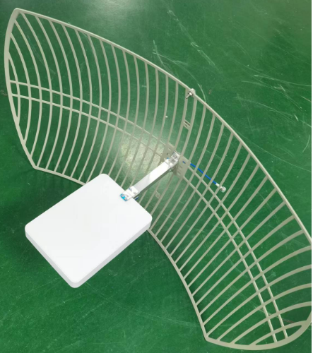
- Elegant appearance, simple installation, stable performance.
- Good performance in anti-vibration and resistant to aging.
- Small size and Light weight.
- Fit for Outdoor Hold Pole mounted.

Technical Specification:
Frequency | 698 ~ 960 / 1710 ~ 2700MHz
Bandwidth | 262 / 990MHz
Gain | 15/18dBi
VSWR | ≤1.5
Max power | 100W
Impedance | 50Ω
Polarization | Vertical
Horizontal Beamwidth | 20°/25°
Vertical Beamwidth | 30°/12°
Front to Back Ratio | ≥30dB
Rated Wind Velocity | 60m/s
Lightning Protection | DC Ground
Weight | 2.8kg
Color | Grey
Dimension | 900×600×600mm
Connector Type | N-Female or customized
Ingression Grade | IP65
Terminal line | white 3D-FB, L=30mm
Radiating Element Material | Aluminum Alloy
Radome Material | UV-Resistance ABS

